Aditya Ramesh Jagtap
Email id:- adityajagtap2288@gmail.com
TABLEAU PERFORMANCE TESTING REPORT
Calculated Field Creation and Visualization
1. Objective
The objective of this task is to create a Calculated Field in Tableau using the agricultural production dataset. The calculated field is used to derive a new metric from the existing Area and Production fields and visualize the result.
2. Dataset Used
Dataset: India Agricultural Crop Production Analysis (1997–2021)
Important fields used: Area, Production, State, Crop, Season and Year.
3. Calculated Field Created
Calculated Field Name: Production per Area
Formula:
SUM([Production]) / SUM([Area])
4. Procedure
1. Open Tableau Desktop and connect the agricultural Excel dataset.
2. Open the worksheet after loading Sheet1.
3. Right-click in the Data Pane and select Create → Calculated Field.
4. Enter the calculated field name as Production per Area.
5. Enter the formula SUM([Production]) / SUM([Area]).
6. Click OK to create the calculated field.
7. The new Production per Area field appears in the Data Pane.
8. Drag State to Rows and Production per Area to Columns to create a state-wise visualization.
9. Use a Bar chart and sort the values in descending order for easier comparison.
5. Purpose of the Calculated Field
Production per Area measures agricultural production relative to the cultivated area. It helps compare production efficiency across different states and can also be analyzed by crop, season or year.
6. Result
A new calculated metric named Production per Area was successfully created in Tableau. The metric can be used in visualizations to compare agricultural production relative to area.
7. Performance Testing – Number of Calculation Fields
Number of Calculated Fields Created: 1
Calculated Field: Production per Area
8. Screenshots to Include
Figure 1: Calculated Field window showing the Production per Area formula.
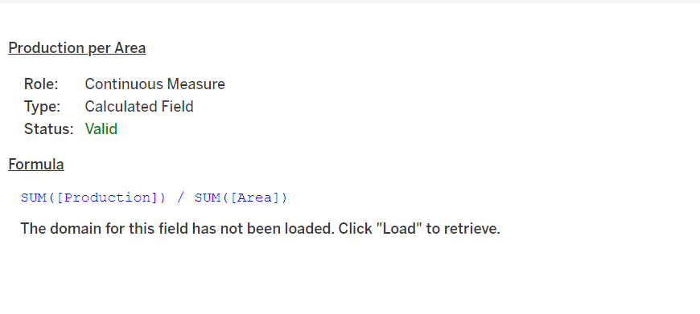
Figure 2: Production per Area by State visualization.
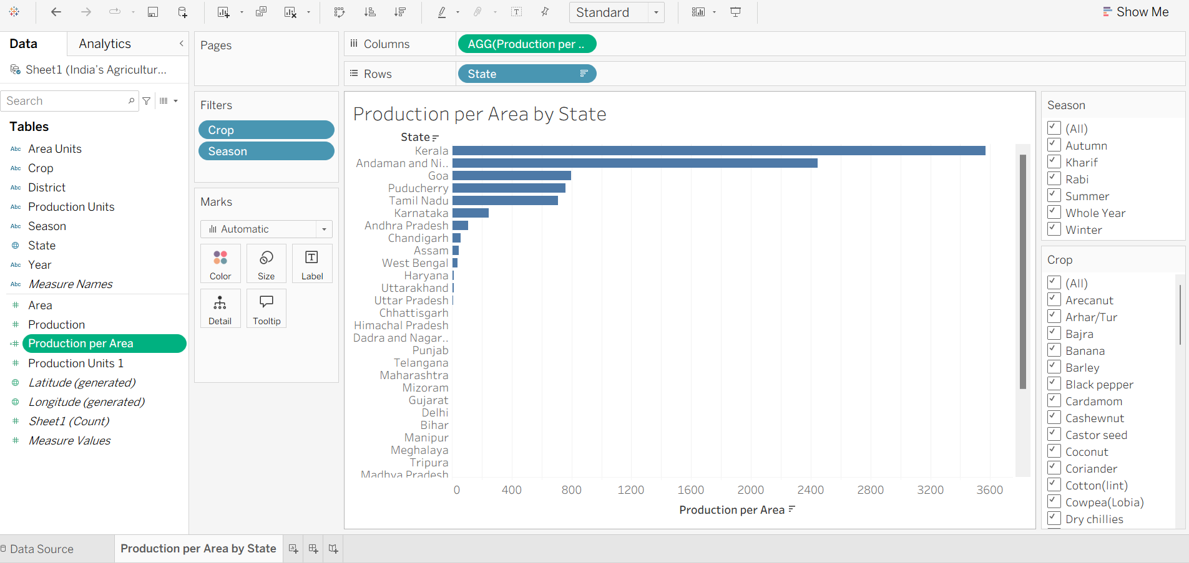
9. Conclusion
The Calculated Field feature in Tableau was successfully used to create a derived metric from the agricultural dataset. Production per Area provides an additional analytical measure that can support comparison and interpretation of agricultural production.

